Experience
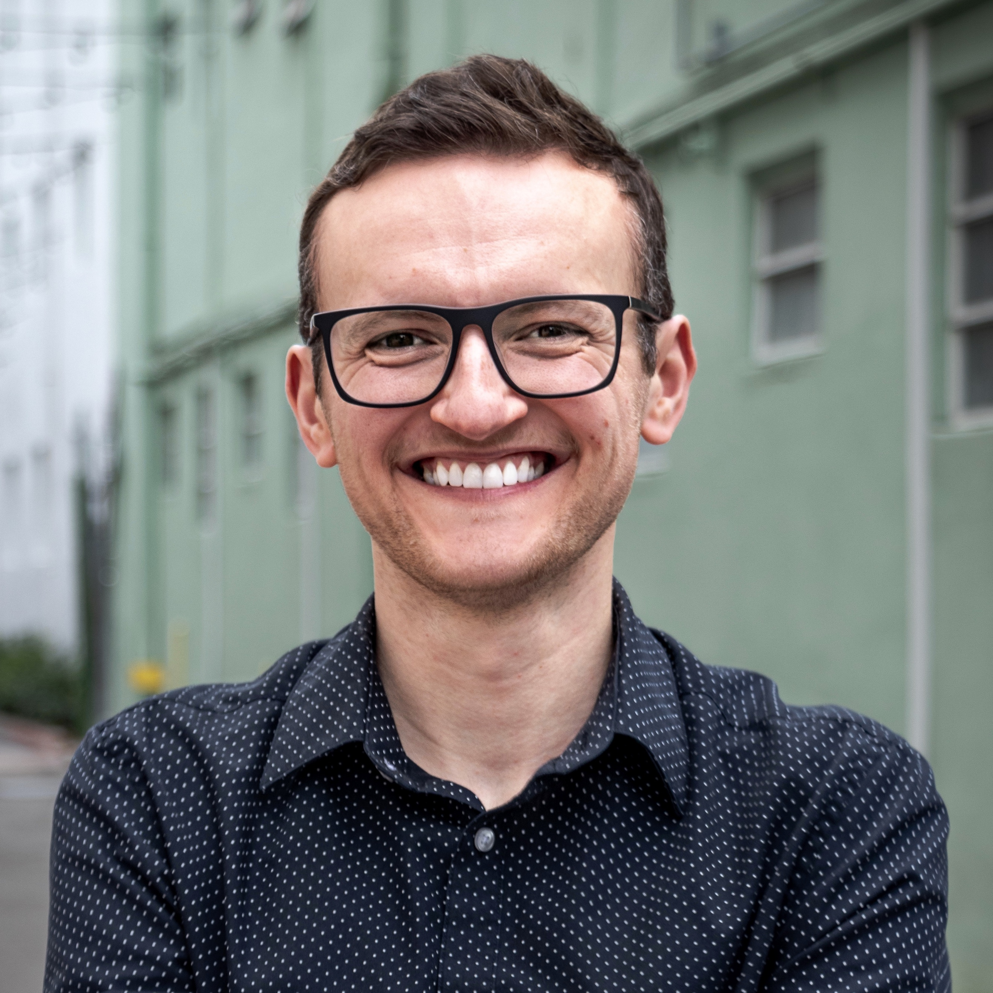

Eliot M. Lev
  - pronouns: he/him/his
eliotmartinlev@gmail.com
(312) 399-1596
eliotlev.com

summary
After a successful career as a professional violinist, I am pursuing a path in the mental health field. I bring a strong work ethic, an apt mind, and a passion for advocacy, critical thinking, and compassion to my counseling and research pursuits. I am especially interested in working with sexual and gender minority, multicultural, immigrant/asylum people, and people with disabilities; as a member of these communities myself, I am deeply invested in using my lived experience to serve others.

Skills and abilities
Multicultural, compassionate approach
Bilingual (English/Russian); beginner Spanish
Excellent written and oral communication
Seeking Safety and Harm Reduction protocols
Mediation experience
Proficiency at Microsoft Suite
Math and analytic skills
Excellent organizational skills
Motivated self-started and team player
Experience in the treatment of multiply diagnosed people
Experience working with diverse communities in non-traditional settings

Progress House | Progress Foundation

Counselor | 06/2020-present
Provide 1:1 and group client-centered counseling in a 90-day residential mental health program Facilitate weekly DBT-, ACT-, and mindfulness-based groups Create individualized treatment plans and attend case conferences Coordinate residents’ activities Conduct intake interviews and coordinate discharge plans Create and facilitate regular research- and social justice-based trainings for staff Develop and maintain relationships with clients' psychiatrists and related treatment programs

San Francisco Community Health Center

Care Navigator | 03/2020-07/2020
Work with HIV+ people experiencing homelessness, especially people with substance use and/or mental health challenges, refugees, political asylees, immigrants and/or undocumented individuals
Link persons served to psychosocial and primary care services
Advocate for clients with other service providers
Provide peer-counseling and practical services
Empower clients in building their own support networks

Alliance Health Project, UCSF

Peer Counselor | 06/2019-present
Facilitate weekly 2-hour peer support groups for long-term 55+ HIV survivors of diverse backgrounds
Encourage exploration of emotions and promote cultural humility
Help manage conflict
Implement Seeking Safety and Harm Reduction models
Connect group members with the appropriate community resources
Reflect on the progress of the group in weekly 1:1 and monthly group supervision

UCSF Community Health Systems, Sexual and Gender Minority Health Equity Lab

Research Assistant | 02/2019-present
Work in a highly productive multidisciplinary team
Conceptualize and carry out ancillary studies for the PCORI- and NIH-funded PRIDE study (UCSF-Stanford)
Research background literature
Analyze data
Write scientific papers
Present findings at regional and national conferences
Advocate for the improvement of LGBTQ+ care and policies

Benioff Children's Hospital, SF

School Room Volunteer | 12/2018-07/2019
Work with patients 1:1 bedside
Assist patients and siblings with educational activities
Support student-centered learning in various settings
Provide educationally themed play for school-aged patients and siblings
Embody and promote compassion and cultural humility

No One Dies Alone Program | Palliative and Spiritual Care, UCSF
On-Call Volunteer | 04/2019-present
Provide emotional, intellectual, sacramental, religious and spiritual support to patients and families through the dying process
Empower clients
Provide companionship and comfort
Work with the interdisciplinary team in the overall care of the patient

Education

UC Berkeley Extension | Post Baccalaureate in Psychology and Counseling | 2018-19
Upper division courses in Developmental, Clinical and Psychology of Personality, Research Methods, and Statistics. GPA 4.0

Roosevelt University |Bachelor of Music | 2006-08
Member of the Franklin Honors Society
Summa cum laude, GPA 3.82
Recipient of a full merit-based scholarship

Publications and presentations
Lev, E.M., Flentje, A. Teaching the DSM-5: Countering discriminatory language with sexual and gender minority-inclusive pedagogy. Poster presentation at APA 2020 (manuscript in preparation)
Vivid, J, Lev, E.M., Sprott, R.A. The four dimensions of kink identity (Journal of Positive Sexuality, 2020)
Lev, E.M., Vivid, J., Sprott, R.A. Kink and sex through the lens of queer theory: Findings from the Kink Identity and Sexuality Study. Recipient of the Student Research Award at the Positive Sexuality Conference 2020, Los Angeles, CA.

Clark, K.D., Lev, E.M., Lunn, M., Trujillo, M., Obedin-Maliver, J., Flentje, A. State level policies and their association with victimization among sexual and gender minority people (in press)

Sprott, R. A., Vivid, J., Vilkin, E., Swallow, L., Lev, E.M., Orejundos, J., A Queer boundary: How sex and BDSM interact for people who identify as kinky (Sexualities Journal, 2020)

